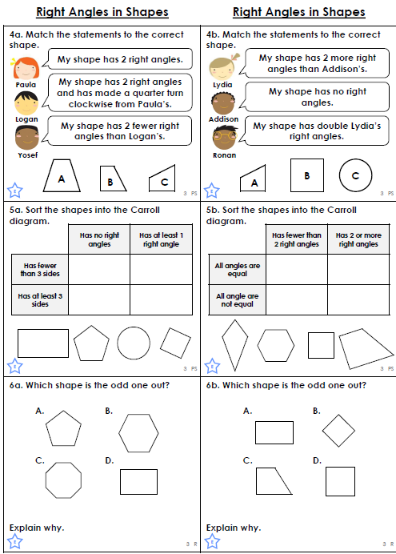

Y3 MONDAY

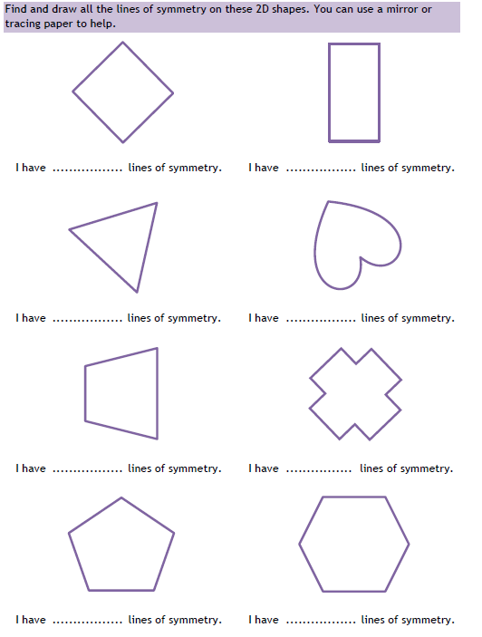

Y3 TUES

Y3 WEDS

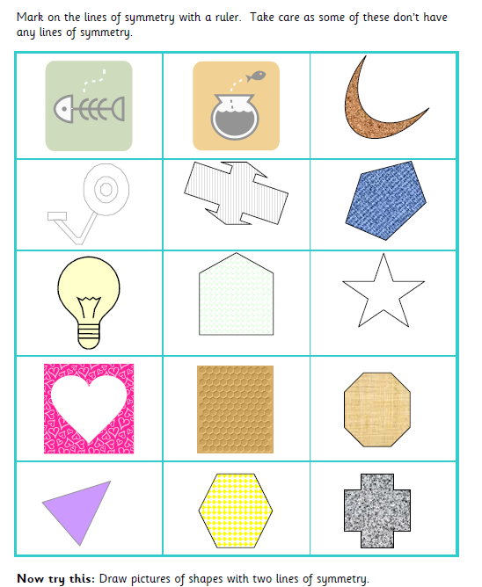

Perimeter

Y3 THURS

Find the perimeter of these shapes.

7cm

**Additional Challenge:**

Draw a rectangle.

Carefully measure the length of its sides.

Record the perimeter.

5cm

8cm

2cm

8cm

9cm

6cm

6cm

6cm

3cm