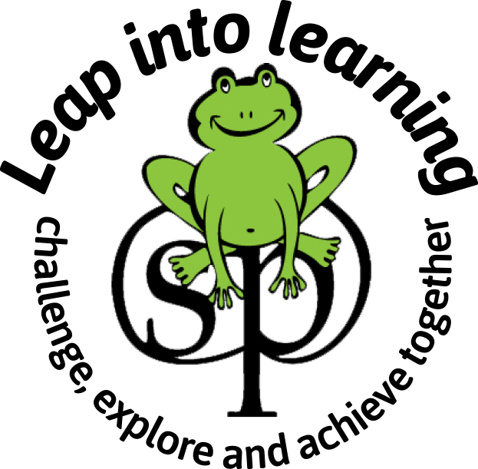
Swavesey Primary School
Middle Watch, Swavesey,
Cambridge. CB24 4RN
www.swavesey.cambs.sch.uk

Head Teacher: Mrs Lynsey Ogilivie Telephone: (01954) 273312 e-mail:office@swavesey.cambs.sch.uk

24th April 2026

Dear Parents/Carers,

Welcome to the Summer Term. We hope you had a lovely Easter break.

This term we are excited to start our next topic, which will be Where we Live – a unit of work linked to our local area and the village of Swavesey (please see enclosed overview). If you have any knowledge or resources, you would like to share please send them (named) to school with your child or contact your child’s class teacher.

To support our learning this term we will be going for a walk in the village linked to our Geography curriculum. There will be a letter with more information sent out about this later in the term, which will also ask for any parent volunteers to support with ensuring that the local area visit can go ahead.

In addition this term, we will be going on a visit to the Cambridge Botanical Gardens to look at a variety of plant life to enrich the children’s learning in science. You should have already had all the information linked to this trip already, but please do contact your child’s class teacher if there is anything additional you would like to know.

Please ensure your child wears their named PE kit, have any earrings removed and long hair tied back on their PE days. All the classes will continue to have PE on a Monday, with Foxes and Otters having their second session on Wednesdays and Squirrels class continuing to have theirs on a Thursday.

Your child will receive their spelling and maths homework via Purple Mash 2email on a Tuesday. Spellings and maths facts will be tested the following Tuesday. If you need any support with Purple Mash please contact your child’s class teacher. Your child should aim to practise these spellings and maths facts for a few minutes every day. They will be tested on the following Tuesday.

Please continue to read, share and enjoy books with your child daily. We will continue to send school reading books home but please remember to return these promptly once read.

Your child will bring home a new grid of termly topic homework activities linked to our Where we Live unit. Once a piece of work has been completed a photograph can be uploaded to Purple Mash or the work can be sent into school for your child to share with the class on a Friday. Work uploaded to Purple Mash can be accessed by your child’s class teacher and then be shared with the class. At the end of term, certificates and smiley faces will be awarded for their hard work.

If you need to discuss anything in this letter in more detail, please don’t hesitate to speak to your child’s teacher.

Thank you for your continued support,
Year 1/2 teachers

