Feeling boo
ART
Children will learn about:
Drawing, making and sculpture to develop and share their ideas, experiences and imagination.
They will use a range of materials creatively to design and make works of art.

HISTORY
Children will learn about:
Similarities and differences between Swavesey now and in the past.
Significant events, people and places in their own locality.
Use different sources to find out about life in Swavesey in the past

DT
Children will learn:
Where different food comes from including naming common fruit and vegetables. Using the basic principles of a healthy and varied diet they will design and make their own fruit kebab.

ENGLISH
Children will:
Read and write a variety of genres including a narrative linked to The Tiger Who Came to Tea, poetry, recounts and information leaflets about Swavesey.
Learn to use grammar and punctuation including capital letters, full stops, question marks and exclamation marks, suffixes, grammatical patterns in a sentence, apostrophes and commas.

RE:
Children will explore the question:
What does it mean to be a person of the Hindu faith?

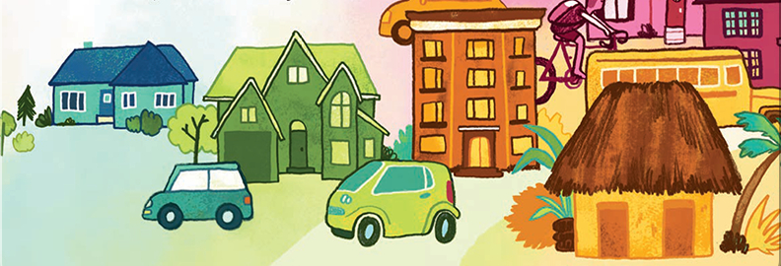
COMPUTING
Children will learn:
To create and debug simple programs.
Use logical reasoning to predict the behaviour of simple programs.
Use technology to represent information in different ways.
To recognise common uses of information technology beyond school.

Where We Live
YEAR 1/2
Summer Term 2026

PE
Children will learn:
Tennis related skills and basic fundamentals such as travelling with control and throwing and catching with accuracy.
The basics of throwing catching and fielding in Cricket.
Athletics skills including running, throwing, jumping in preparation for Sports Day.

PSHE
Children will learn about:
Myself and my relationships.
Healthier and safer lifestyles.
Rights, rules and responsibilities.

MATHS
Children will:
Continue to explore number, calculation, money, fractions, time, shape, statistics, weight, length, position and direction.

MUSIC
Children will learn to:
Use their voices expressively by singing songs and speaking chants and rhymes.
To appreciate and understand a wide range of high quality live and recorded music drawn from different traditions and from great composers and musicians.
Experiment with, create, select and combine sounds using the interrelated dimensions of music.
Listen with concentration and understanding to a range of high quality live and recorded music.

SCIENCE
Children will learn to:
Identify and name a variety of common wild and garden plants, including deciduous and evergreen trees
Identify and describe the basic structure of a variety of common flowering plants, including trees.
Observe and describe how seeds and bulbs grow into mature plants. Find out and describe how plants need water, light and a suitable temperature to grow and stay healthy.
Observe changes across the four seasons and observe and describe the weather associated with the seasons and how day length varies.

GEOGRAPHY
Children will learn to:
Use simple compass directions and locational and directional language to describe the location of features and routes on a map.
Use simple fieldwork and observational skills to study the geography of their school and its grounds
Devise a simple map and use and construct basic symbols on a key.
Use aerial photographs and plan perspectives to recognise landmarks and human and physical features
Name and identify human and physical features of our local area.

