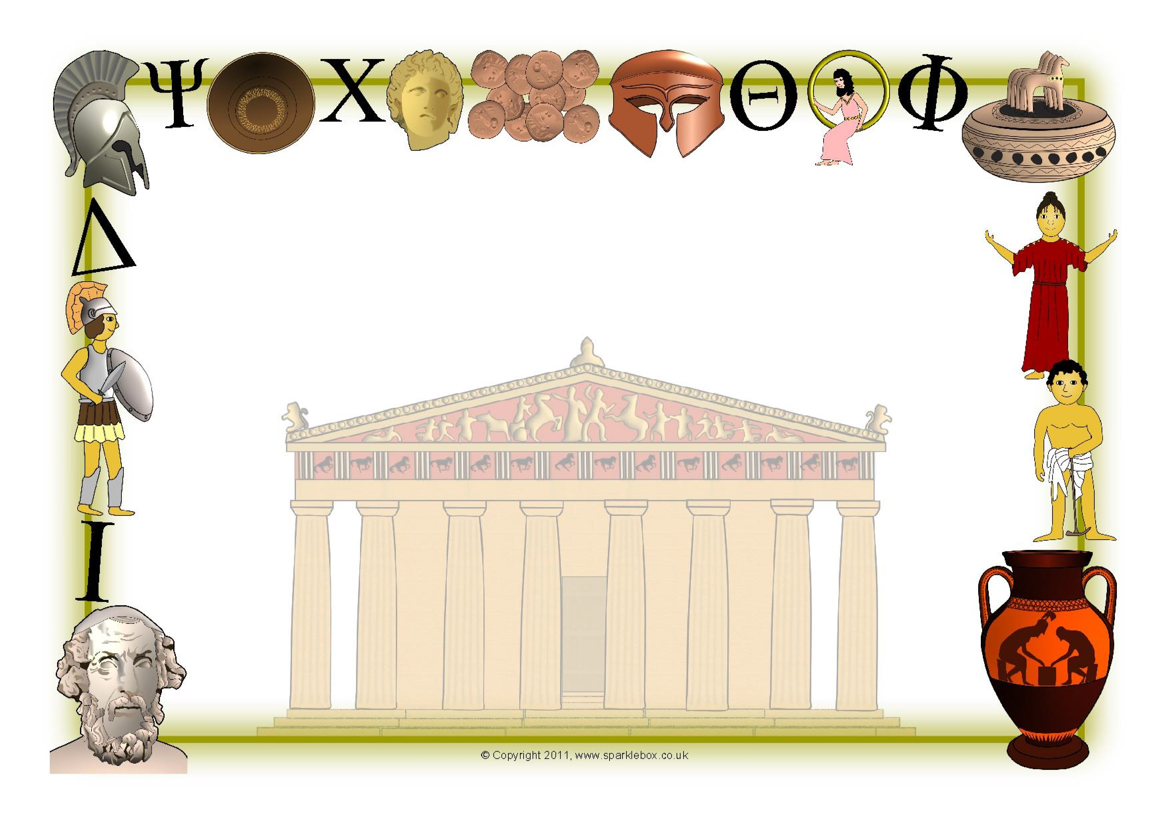

Year 3/4 Homework:

Choose from the activities below. We would like you to make a project out of it by including planning, photos and a write up

,

Research Greek food

–

cook
a
Greek dish
or m
eal
that you might eat in a
restaurant.

Find out about famous
Greek

people, such
as

philosopher
s
, scientists or athletes.

Who were they? What did they find out?

Create a presentation on your computer
about an aspect of Ancient Greek life of
your choi
ce.

Visit
a Cambridge museum, such as the
Fitzwilliam museum,

to find out about
Ancient Greek life

.

Imagine that you were living in Ancient
G
reece. Describe

y
our house and include
a picture or model.

What does it look like?

What furniture do you have
?

Write a poem or song about life in
Ancient
Greece

or modern-day Greece.

Imagine that you survived

one of the
Ancient
Greek bat
tles. Write a diary
extract, st
o
r
y or newspaper report about
your experiences.

Make a mod
el of a Greek ship or a Greek

building such as

The Parthenon

Imagine you are a travel agent trying to
promote Greece as a place to go on
holiday.

Be persuasive and encourage people to want to visit.

Year 3 and 4 Summer Homework Project
Look carefully at the activities below. Choose one that you would like to turn into a project. This might include planning, taking photos as well as making something. You might want to include an evaluation too.
Your homework project must be completed by Monday 29th June so that there is time to share it with your class.

