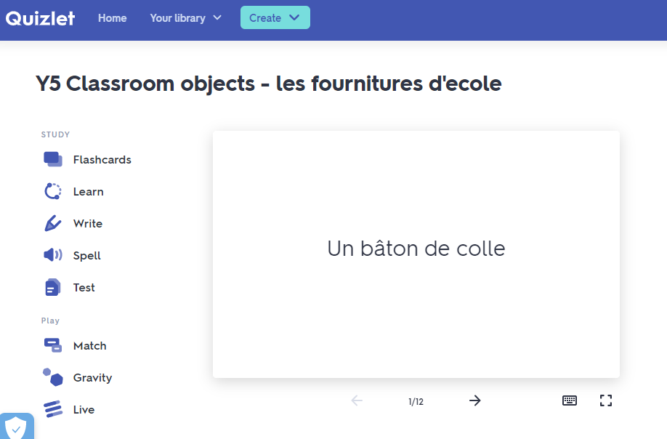
QUIZLET
How to access Quizlet
  - Go to: https://quizlet.com
  - Click ‘sign up’ and create an account with a password
  - Complete log in details with your email address
  - Click continue with ‘free Quizlet’
  - Choose the box ‘classes’
  - Go to the search box and search for Swavesey primary school

Name of the set: Y5 Classroom objects - les fournitures d'ecole

STUDY
  - Or alternatively you can click on the following link without register
https://quizlet.com/_9dfvld?x=1jqt&i=wxd6x
Language Angels

  - Go to: https://languageangels.com/school/
  - Click login
  - Choose login pupil games
  - Complete username(stps) and password(french) and login
  - Choose a device
  - Click to French
  - Choose the topic En classe (in class)
  - You can review any other topics too
  - The school has an annual membership


DUOLINGO
Duolingo Is an excellent addition to a language learner's toolbox. It's easy to use, it's fun, it’s free and it works.
  - Go to: https://duolingo.com
  - Click ‘sign up’ and create an account with a password
  - Complete log in details with your email address
  - Try to practise every day 15 min

Thank you for supporting this with your children. We really believe it will make a difference to their learning.

Madame Millard

