La recette de la galette des rois

I hope you enjoyed the video on the cooking of "la galette" last week. Below you will find the words for the ingredients and the 6 steps recipe. You will also find images of the ingredients and the cooking steps in pictures.

- Stick the ingredients of the recipe for "la Galette des rois".

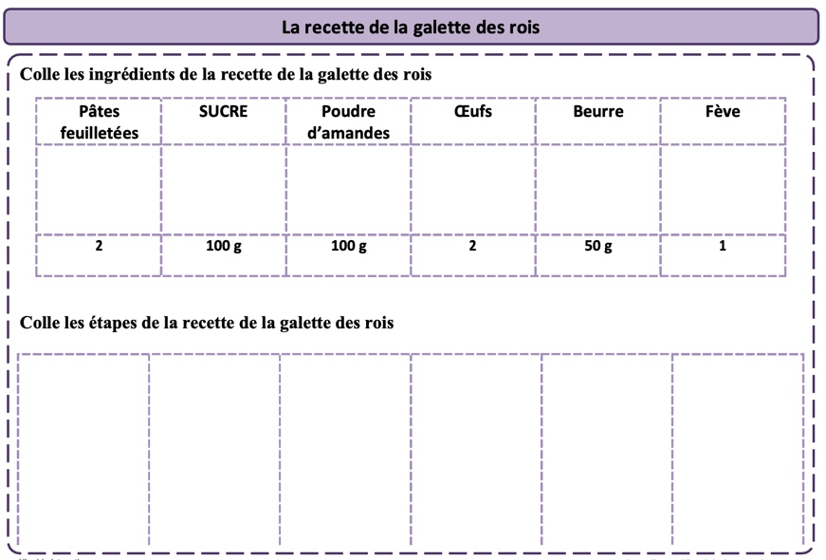
- Stick the steps of the recipe for “la galette des rois”.


